The forgotten schools of the Zambezi River

Project Information
Project Name | Nabunjebwa Primary School support project
Project Location | Hwange, Matabeleland North Province, Zimbabwe
Primary Sector | Education
Proposed Total Budget | $15 920
Date of submission | 27 June 2018

Project Background and Problem Statement
Zimbabwe has a myriad of challenges in its quest to deliver high quality education. These include shortage of trained teachers and learning materials; low teacher morale/motivation and shortage of and/or dilapidated school infrastructure. The authorities lack funds needed for education infrastructural development or maintenance, leaving many schools rundown and children learning in open spaces or dilapidated buildings. Only a third of primary school classrooms are in an acceptable condition. The situation is dire in remote and underserved districts such as Hwange district. The poor condition of schools contributes to school drop-outs, poor results, and teachers’ transfers. In this district most of the primary schools use composite classes due to shortage of classrooms blocks (more than one grade using the same classroom room and taught together) and some classes are conducted under trees. The challenges bedevilling the education sector in Hwange district leads to poor performance at key schooling levels like grade 7 and ordinary level. The grade 7 pass rates for Hwange were significantly below the national average in 2014, at 22% compared to 38% in 2014 for the national average; and also far below the 50% target in 2015.

The target primary school for this project, Nabunjebwa had a 0% pass rate at grade 7 final examinations over the last 3 consecutive years. One of the key contributory factors for the poor performance at Mwemba primary school is the poor learning and teaching environment. The school which lies on the bank of the Zambezi is one of the remotest schools in the district of Hwange which has proven to be inhospitable for many teachers, shown by the perhaps one of the highest teacher turnover rates. For many years, the school has relied on untrained community volunteer teachers who were paid through community donations. The school lacks standard teacher’s accommodation; teachers have used storerooms within the classroom as living quarters until recently when the community came together to build a small shack which operates as a teacher’s cottage. The cottage does not have a toilet or a bathing facility such that teachers have to use the bush for open air bucket showers and also ablutions. Currently the school has two lady teachers that run composite classes of several grades levels in one classroom. These factors are a put-off to most teachers which result in high attrition rate of teachers to better resourced school, which has seriously disadvantaged the children of Nabunjebwa village. The teachers also have to walk more than one km to fetch water from the community borehole which further complicates the life of the teachers.

Project Description
The project seeks to improve the quality of education by ensuring a safe and conducive learning environment and teaching environment through the following long-term interventions.

Vulnerability | Proposed intervention
Poor teacher accommodation has made life miserable for the few teachers that brave to be deployed at the remote school; This has caused a rapid teacher turnover to the detriment of childrens education. | Support the community to establish one low cost teacher’s cottage to improve the teacher’s living conditions.
Poor access to clean water at the school; teachers and children have to fetch water from a borehole 1 km away which exacerbates teacher and pupil misery. | Support the school to drill and equip one borehole with a bush pump within the school yard.
Lack of ablution facilities for the teachers leading to diminished quality of life which fuels teacher flight; Teachers are currently forced to use the bush for ablutions and bathing. | Support the community to construct a simple blair toilet.
Critical shortage of stationery and text books which seriously compromises the quality of teaching and learning. | Support the school with teacher and student stationery and text-books

Each intervention can be done one at a time depending on the funding availability and cashflows.

This project is in line with Zimbabwe’s Ministry of Primary and Secondary Education Medium Term Strategic Plan 2011-2015 which foresees the construction and renovation of over 26,000 classrooms. The Government is indeed constructing and rehabilitating classrooms, but the task is huge and needs contributions from development partners. The project will also contribute towards attainment of the Sustainable Development Goals, notably the one on inclusive and equitable quality education (SDG 4).

Local Participation
The local stakeholders that would participate and their roles in the project are shown in table below:

Stakeholder(s) | Role in Project
Ministry of Public Works | - This Ministry will provide the plan for the teacher’s cottage as per government policy and will also monitor its construction to ensure adherence to technical standards.
Ministry of Primary and Secondary Education (MoPSE) | - The MoPSE district Inspector will also monitor the construction of the cottage to ensure that it meets the minimum functionality standards.
Hwange Rural District Council (RDC) | - Assist in siting, the pegging and support with carpentry work for roofing the cottage, the RDC will also support the community with bricks.
Schools Development Committees (SDCs) | - The SDC will mobilise community members to contribute labour and locally available materials for the construction  - Assist the head teacher in coordinating the construction of the teacher’s cottage
Councillor, Headmen and Ward Development Committee | - These local stakeholders provide an oversight role, in which they ensure that resources advanced to the school are used properly and through their usual mandate are required to solve any challenges that emerge together with the school authorities.

Project Sustainability
The project will involve active participation of parents/ caregivers, parents, SDC and teachers at Mwemba primary school who will be responsible for the maintenance of the established classroom block. The MoPSE and Hwange RDC will also assist help to ensure the upkeep of the new facility. The Ministry of Education and the Hwange Rural District Council will continue school inspections after project duration.

Project Budget
The total project budget is $15 920. This amount doesn’t cover labour costs for builders and other community contribution through manual labour, sand and bricks.
Item | Budget
- Teachers cottage building materials | $7 620
- Blair toilet | $300
- Stationery and textbooks | $1 000
- Wet borehole drilling and bush pump | $7 000
Total | $15 920

Nabunjebwa in pictures
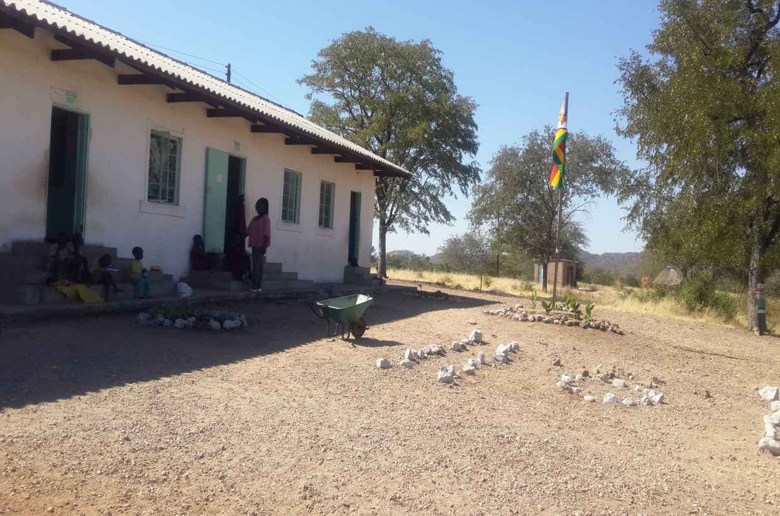
One of the two teachers at Nabunjebwa stands infront of the school’s only classroom block

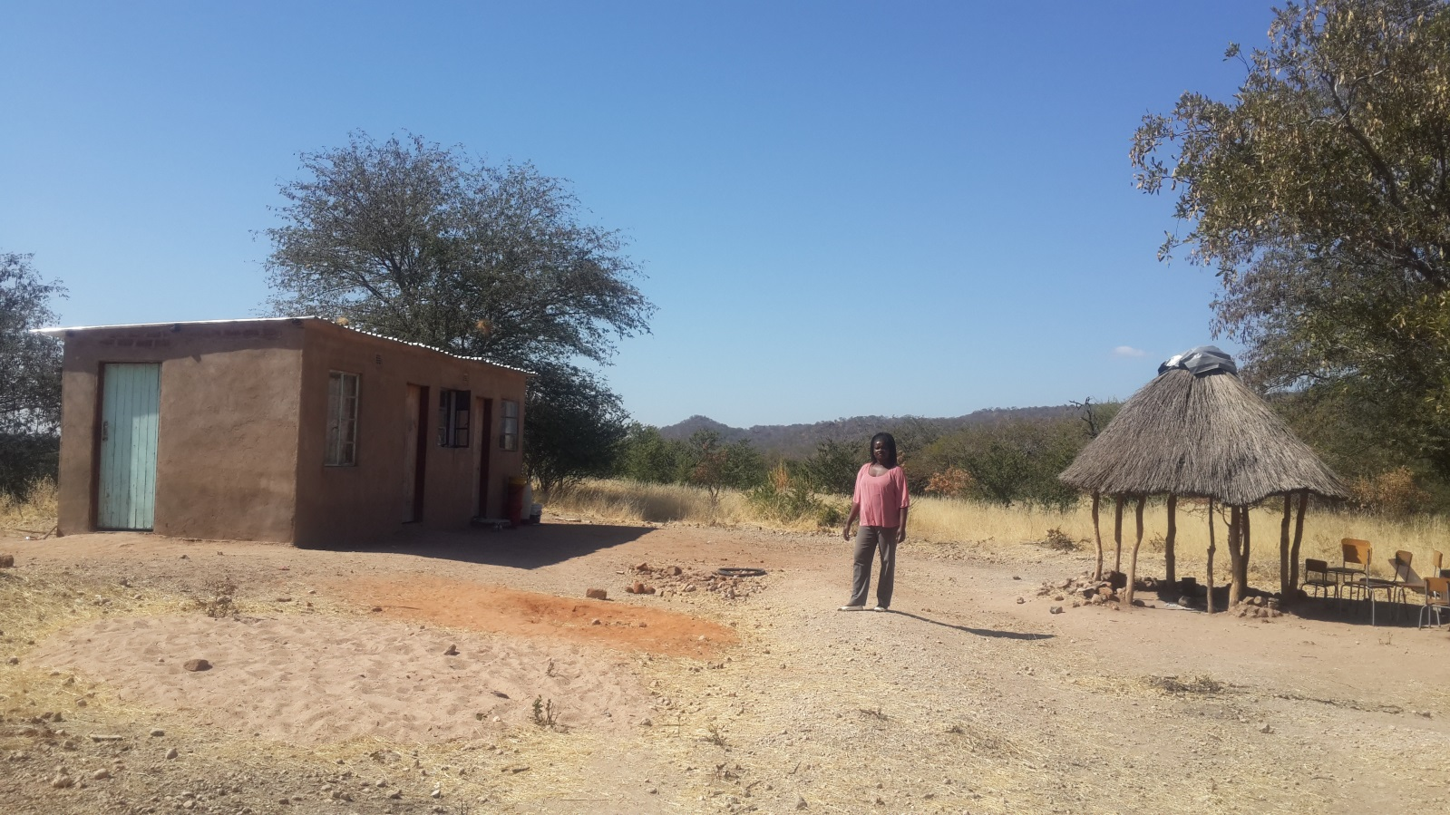
A sub-standard teacher’s cottage and cooking shed built by the villagers; the structure has un-plastered walls inside and the roofs leak in the rain season.
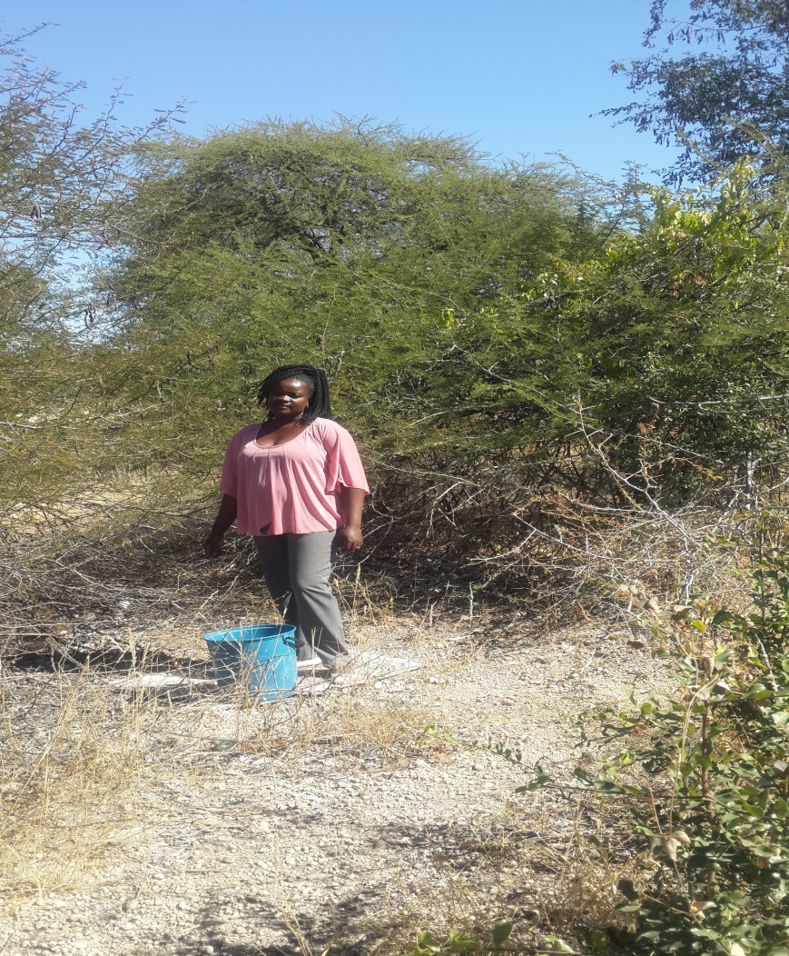
“We have no toilet or bathroom for teachers; we do bucket showers in the open bush very early in the morning or evening to avoid been seen by the public”.

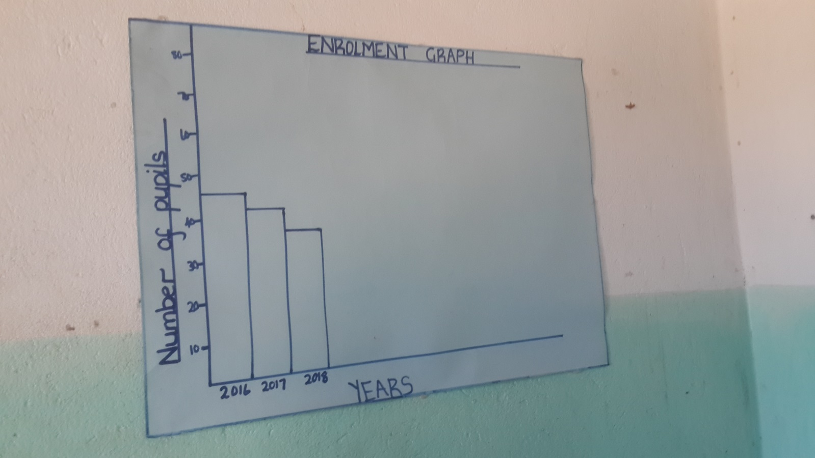
Nabunjebwa enrolment graph: decreasing enrolment-the school is dying unless something is done to support it.

2011 National Schools Census Report

